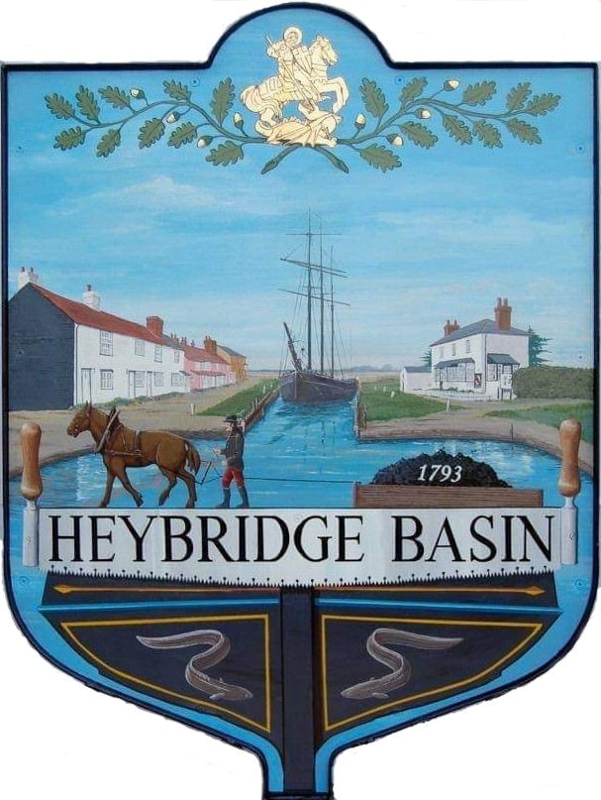

HEYBRIDGE BASIN PARISH COUNCIL

Minutes of the Full Council meeting of Heybridge Basin Parish Council held on Tuesday 12th December 2023 at 6.30pm, at The Lock Tea Room.

PRESENT

In the Chair: M. Hodges Apologies: C. Edmond

Councillors: J. Sjollema Absent: 0
C. Swann
R. Bryson District Councillors: 0
M. Hobden
G. Howat Public: 0

Officers: G. Lake – Clerk

It was noted that this meeting was being recorded by the Clerk.

23/131 Chair’s Welcome
Cllr Hodges opened and welcomed everyone to the meeting. It was reported that the Community Speed Watch was up and running and was having a good effect.

23/132 Apologies for Absence.
Apologies were received from Cllr Edmond.

23/133 To receive Declarations of Interest in accordance with the Council’s Code of Conduct and with section 106 of the Local Government Finance Act 1992.
Cllr Hobden – Non-Pecuniary – HBSA, Basin Oars and HB Rivercare; Cllr Howat – Non-Pecuniary – HBCSA and Cllr Swann – Non-Pecuniary – DMCP and owner of the tearoom.

23/134 To sign as a correct record the minutes of the full council meeting held on 14th November 2023.
The Minutes as previously circulated were agreed as a correct record.

23/135 To sign as a correct record the minutes of the extraordinary meeting held on 1st December 2023.
The Minutes as previously circulated were agreed as a correct record.

23/136 To receive a report from the District and County Councillors for the area on any matters of interest.
There were no reports from the District or County Councillors.

23/137 Unmetered Electricity Supply
  - To consider the renewal quote from SSE and agree any action to be taken.
The Clerk advised that the quotation received was null and void due to the supply number belonging to streetlights in Southend-on-Sea. The Clerk is investigating the matter and will aim to have an update for the January meeting.

23/138 Finance.
- To approve
- Payment requests for November/December 2023.
The Payments as previously circulated were approved.
- Receipts for November/December 2023.
The receipts as previously circulated were approved.
- To review Budget and consider setting the precept for 2024/2025 and agree any action to be taken.
It was resolved to transfer £20,000 from the HBPC Account to the Instant Access Savings Account.

Discussions took place on items under various budget headings and consideration was given to each item and a budget forecast was proposed for 2024/2025.

It was resolved to pay 1/3rd of the Clerks salary, Internal Audit and External Audit costs from the HBPC Account and 2/3rds from the DMCP Account.

The Council agreed the proposed Precept of £31,500 for 2024/2025 which is a 7.35% decrease from the current financial year 2023/2024.

23/139 Public Forum
There were no members of public.

23/140 Planning Applications
- To consider any planning applications received after the publication of the agenda and to agree the action to be taken.
There were no planning applications.

23/141 Village Design Statement (VDS)
  - To receive an update from the Working Group
Cllr Howat previously circulated a report and recommendations from the Working Group. It was resolved that Cllr Howat would consult with the Chair of the Conservation Society and that the Working Group would produce a survey for residents.

23/142 Daisy Meadow Car Park (DMCP)
- To receive an update from the Working Group and agree any action to be taken.
It was noted that the surveys from Haydn Evans are likely to take place on 8th January 2024 and that it would be the end of January for the Council to receive the completed design.

The Clerk recommended that an EGM is called as soon as the design is received in order to consider the design, approve sending to the contractors with a new deadline, setting a date for the Clerk and 2 members to open the new tenders, and choose a number to bring back to another meeting, with the hopes of works commencing in March 2024.

It was resolved to provisionally schedule a meeting for Tuesday 30th January 2024.

It was resolved to advertise the pile of soil building up near the old toilet area for people to take for free.

23/143 Clerk’s Report
- Christmas Tree – It was noted that the Christmas Tree was planted on Saturday 2nd December.
- CiLCA – Following the Clerks appraisal, as of January 2024 the Clerk will be dedicating Wednesdays for CiLCA studies only.
Cllr Hodges thanked the Clerk for her work on her CiLCA studies and informed members that they would be required to help with the Clerks workload, where they can, to ensure the Clerk can complete her CiLCA prior to 7th April 2024.

23/144 Correspondence
- To note correspondence received and any actions to be taken.
Correspondence was noted and responses were agreed.

23/145 Local Issues
- To note any items of inclusion on the agenda for the next meeting of the Parish Council.
Newsletter and other items that were not put on the December Agenda.

23/146 Pursuant to section 1(2) of the Public Bodies (Admission to Meetings) Act 1960 it is resolved that, in view of the confidential nature of the business about to be transacted, it is advisable in the public interest that the press and the public be excluded, and they are instructed to withdraw.

There were no members of public to exclude.

23/147 URC
  - To receive an update from the Clerk and agree any action to be taken.
An update was received from the Clerk, and a discussion was held with actions to be taken agreed.

There being no further business the meeting closed at 08:01pm
Provisional Date of the next Council Meeting Tuesday 16th January 2023.

Clerk Contact details: clerk@heybridgebasinpc.org.uk
Website: www.heybridgebasin-pc.gov.uk

